

ITA_User Instruction Manual

Export/Import

*－*Version 1.7*－*

Copyright © NEC Corporation 2019. All rights reserved.

Disclaimer

All the contents of this document are protected by copyright owned by NEC Corporation.

Unauthorized reproduction or copying of all or part of the contents of this document is prohibited.

The contents of this document are subject to change without prior notice in the future.

NEC Corporation is not responsible for any technical or editorial errors or omissions in this document.

NEC Corporation do not guarantee accuracy, usability, certainty of the content in this document.

Trademark

* Linux is registered trademark or trademark of Linux Torvalds, registered in the U.S. and other countries.
* Red Hat is registered trademark or trademark of Red Hat,Inc. Registered in the U.S. and other countries.
* Apache, Apache Tomcat, and Tomcat are registered trademarks or trademarks of the Apache Software Foundation.
* Ansible is registered trademark or trademark of Red Hat,Inc.
* AnsibleTower is registered trademark or trademark of Red Hat,Inc.

The names of other systems, company name and products mentioned in this document are registered trademarks or trademarks of their respective companies.

The® mark and TM mark are not specified in this document.

※ 「Exastro IT Automation」 is written as 「ITA」 in this document.

**Table of Contents**

Introduction 3

1 Export/Import overview 4

1.1 Export/Import function 4

1.2 Modes 5

1.3 Example 6

2 Menu and screen configuration of Export/Import 8

2.1 Menu List 8

3 Function and operation method 9

3.1 Export Menu 9

3.2 Import menu 11

3.3 Export/Import menu list. 13

Introduction

This manual describes the function and the way to operate the Export/Import function in ITA.

# Export/Import overview

In this chapter, we will explain the Export/Import function, its modes, as well as show some examples.

## Export/Import function

To Export/Import, select the menu you want to move and then transfer them my overwriting the data as menu units.

ITA server A

Kym file

Import

Export

Kym file

ファイル

ITA server B

**Selected menus**

Menu A

Menu Ｂ

ﾒﾆｭｰC

Menu C

Menu Ｂ

ﾒﾆｭｰC

Menu C

Menu A

## Modes

The export function has 2 types of modes.

1. **Environment migration**

Exports all the data of the selected menus. It will overwrite all the data of the Import destination.

**All of the data in Menu A will be exported.**

**ITA Server B**

**ITA Server A**

**Menu A**

**Menu A**

**Kym**

**file**

**Data １**

**Data ２**

**Data １**

**Data ３**

**Data ２**

**Data ３**

1. **Time specification**

Exports only data last updated after a specified time.

If the unique items (ID, No, etc.) overlap, the exported data will take priority over the imported data.

Example：If the following date/time is set: 2021/01/02 17:00

**Only Data 2 and Data 3, whose “Last updated” date was after the specified time, will be exported.**

**Data 2 and 3 will be added**

**ITA Server A**

**Menu A**

**Data 1 2021/01/01 17:00**

**Data 2 2021/01/02 17:00**

**Data 3 2021/01/03 17:00**

**ITA Server B**

**Menu A**

**Data 1 2021/01/01 17:00**

**Kym**

**File**

**Data 2 2021/01/02 17:00**

**Data 3 2021/01/03 17:00**

## Example

This example assumes that two environments, ITA Server A and ITA Server B, will be used for the function.

**Pattern ①：Replicating the environment**

All the data registered to ITA Server A will be replicated onto ITA Server B.

Procedure

1. Export all of the data in ITA Server A in using the Environment Migration mode.
2. Take the exported data from step 1 and import it to ITA Server B.

※After importing, users can register and change the data in ITA Server B.

After that, trying to move the same data from ITA Server A again might cause inconsistency errors, so we recommend not doing so.   
※We do not recommend moving data from/to both sides, as this might cause inconsistency errors.

**3. Register and change data**

**1.Input and test data**

※After importing, users can register and change the data in ITA Server B.

After that, trying to move the same data from ITA Server A again might cause inconsistency errors, so we recommend not doing so.

**ITA Server B**

**ITA Server A**

**2.Move all the data**

**ITA**

**ITA**

**Menu A**

**Menu A**

**Menu B**

**Menu B**

We do not recommend moving data from/to both sides, as this might cause inconsistency errors.

**Pattern ②Separate Data input server and Executing server.**

If you want to have 2 servers. 1 server for data entry and testing and 1 for executing operations.

Procedure

1. Export all of the data in ITA Server A in using the Environment Migration mode.
2. Take the exported data from step 1 and import it to ITA Server B.
3. Whenever there data in ITA Server A changes, use the Time Specification mode to import any changed data to server B.

※If you already know that you are going to move data multiple times,

Registering/Changing the data is not recommended, as it might cause inconsistency issues. However, executing operations has not effects.

※When moving data while an operation is running on Server B, make sure to use the Time specification to move only the data that as changed in order to prevent the import having any effect on the running operation.

※We do not recommend moving data from/to both sides, as this might cause inconsistency errors.

**3. Register and change data**

**1.Input and test data**

※After importing, users can register and change the data in ITA Server B.

After that, trying to move the same data from ITA Server A again might cause inconsistency errors, so we recommend not doing so.

**ITA Server B**

**ITA Server A**

**2.Move all the data**

**ITA**

**ITA**

**Menu A**

**Menu A**

**Menu B**

**Menu B**

We do not recommend moving data from/to both sides, as this might cause inconsistency errors.

# Menu and screen configuration of Export/Import

This chapter describes the menu and screen configuration of Export/Import.



## Menu List

The menus of Export/Import are as follows.

**Table 2-1 ITA menu list**

|  |  |  |  |
| --- | --- | --- | --- |
| **No** | **Menu group** | **Menu / Screen** | **Description** |
| 1 | Export/Import | Export menu | Export the data of menu. |
| 2 | Import menu | Import the data of menu. |
| 3 | Export/Import menu list | Manage the status of the exportation executed in [Export menu] and importation executed in [Import menu]. |

# Function and operation method

## Export Menu

Export data registered in the ITA system in each menu.

※When moving data to another ITA environment, the integrity of data may corrupt if the whole menu is not moved together.

1. Select the mode and abolition data to export

List of Modes and Abolition data are displayed below.

Table 3-1 Mode list

|  |  |
| --- | --- |
| **Name** | **Description** |
| Overwrite | All existing data will be deleted and overwritten during import. |
| Postscript | Only data different to the existing data will be added during import.  If the unique key (ID, No. etc) is duplicated, the existing data will keep its priority. |

Table 3‑2 Abolition data list

|  |  |
| --- | --- |
| **Name** | **Description** |
| Normal | Export all normal data. |
| Without disuse data | Export without disuse data. |

1. Select the menu to export

C:\Users\113414A009FT8\Desktop\20160220131903.png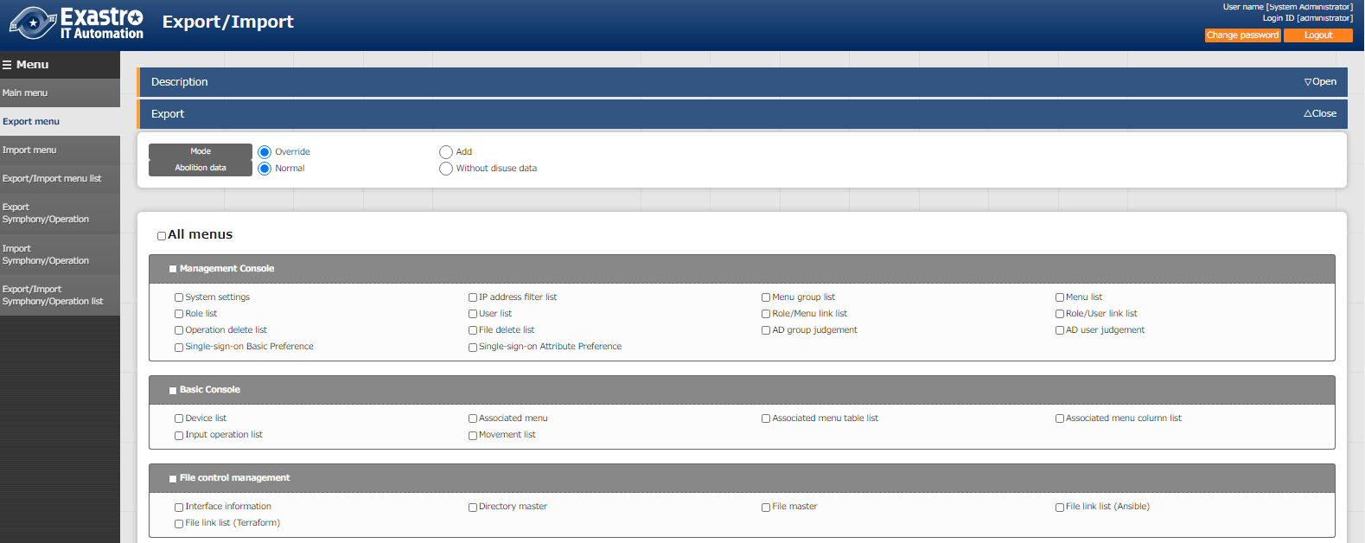



Figure 3‑1 Export menu screen (1)

1. Click the export button after selecting the menu.

The execution number of export operation is displayed, so please check the status of execution in the "Export/Import menu list" screen.



Figure 3‑2 Export menu screen (2)

## Import menu

Import the data exported in [Export menu] menu.

1. Select the file to be imported then click the [Upload] button. 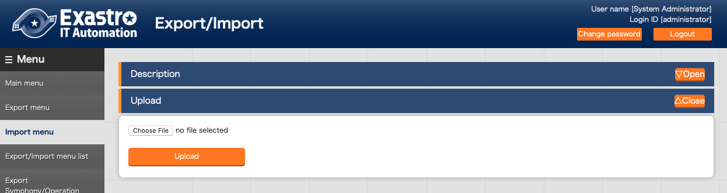

Figure 3‑3 Menu import screen (1)

1. The list of the menu in the imported file is displayed. Select the menu to import then click the [Import] button. Please click [Import (without discarded data)] to import the menu without discarded data.

The menu whose checkbox is checked will be imported.  
Please uncheck the menus that are not needed to be imported.

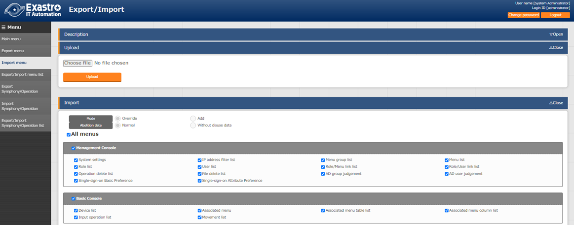

C:\Users\113414A009FT8\Desktop\20160220131903.png

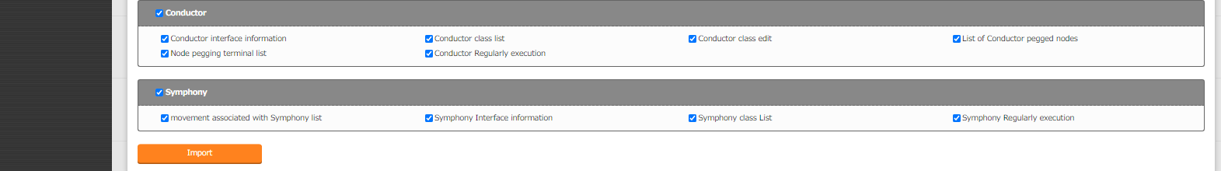

Figure 3‑4 Import menu screen(2)

1. Move to the registration menu. Users can check the status of the migration in the [Export/Import menu list] by clicking the [Export/Import data list] button.

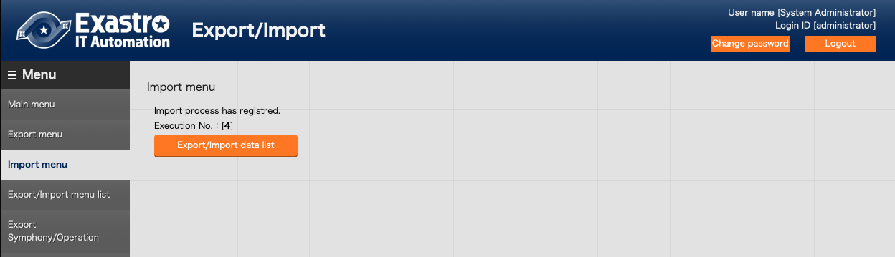

Figure 3‑5 Menu import screen(3)

## Export/Import menu list.

Manage the status of the exportation executed in "Export menu" and importation executed in [Import menu].

The status will change in the order of "Unexecuted", "Executing", "Completed".

The execution type will display "Export" or "Import".

"Overwrite" or "Postscript" will be displayed in the mode.

"Normal" or "Without disuse data" will be displayed in the abolition data.

The import type will be "Normal" or "Without discarded data" if the execution type is import.

Please click the filter button and confirm that the status is "Completed".

In the case of export, if the status is "Completed", the exported data will be displayed in the "File name" column. Please download and use it. In the case of import, the imported data will be displayed in the "File name" column.

If error occurred during import execution, the status will become "Completed (error)".

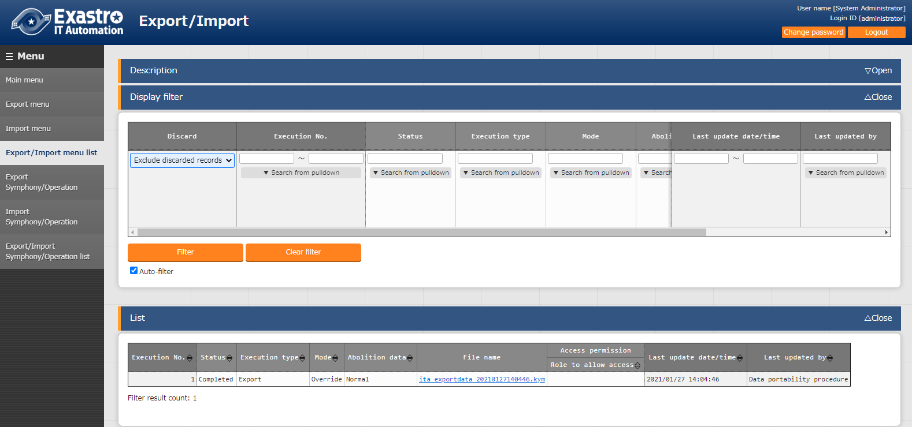

Figure 3‑6 Export/Import menu list

Table 3‑3　List screen item list（Export/Import menu list）

|  |  |
| --- | --- |
| Item | Description |
| Execution No. | Auto generated unique number. |
| Status | Changes in the order of "Unexecuted", "Executing", "Completed".  If error occurred during execution, the status will become "Completed (error)". |
| Execution type | Export・・・Export menu  Import・・・Import menu |
| Mode | "Overwrite" or "Postscript" will be displayed. |
| Abolition data | "Normal" or "Without disuse data" will be displayed. |
| File name | In the case of export, if the status is "Completed", the exported data will be displayed in the "File name" column. Please download and use it.  In the case of import, the imported data will be displayed in the "File name" column. |